CANADA’S RESPONSE TO WW1
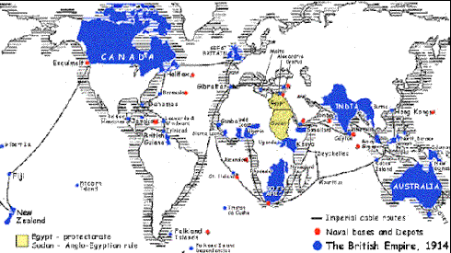
- In __________ Canada was still a dominion of Great Britain
- Great Britain still controlled its _____________ foreign policy
- This meant that when Britain went to war Canada, along with the rest of the_________________ ______________, also went to war.
SUPPORT
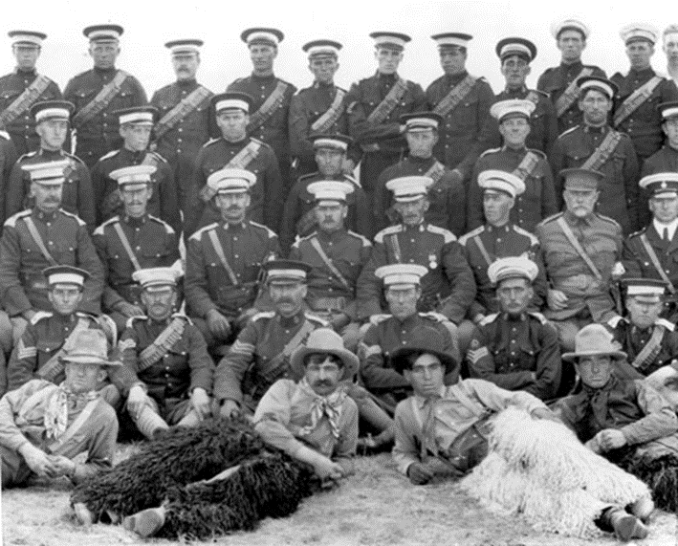
- Canada __________________ entered the war as part of the British Empire
- ________________ for going to war in Europe was widespread
- Canada offered Britain a force of ___________ men trained, equipped, and paid for by the Canadian government
- While Canada only had 3 000 regular army soldiers, it had over ___________________ militia (citizen soldiers trained for emergencies)
- In 1914, Newfoundland was not a part of Canada, so while some Newfoundlanders joined Canadian regiments, most became members of the ____________________ ______________________
- To supplement Canadian forces, the government sent out a call for volunteers to join for $1 a day – over ___________________ Canadians volunteered
THE PEOPLE’S RESPONSE
- Responses to Canada’s involvement in the war varied.
- Those Canadian’s of ________________ decent were enthusiastic, while the __________________ (native French speaking) and population and the Maritime provinces were far less interested in Canadian involvement in a war overseas.

WHY DID THEY JOIN?
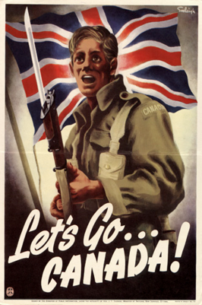
- Sense of __________________________ – Canadians felt proud to fight for their country, and many English Canadian felt strong sentimental ties to Britain (remember that recent immigrants from Britain were the first to volunteer)
- Feelings of ________________________ and _________________________ – many young men viewed war as a “great adventure,” a chance to see the world, and the opportunity to be a hero
- The Toronto ‘Mail and Empire,’ Aug 5 1914.
Cheer after cheer from the crowds of people who waited long and anxiously for the announcement of Great Britain’s position in the present conflict in Europe greeted the news that the Mother Country had declared war against Germany. Groups of men sang “Rule Britannia,” others joined in singing “God Save the King”; some showed their sense of seriousness of the situation by singing “Onward Christian Soldiers”…
- Originally PM Robert Border offered Britain ___________________ troops, but ___________________ signed up in the first month.
- Largely people thought the war would be over by __________________________.
WAR FOR EVERYONE
- Women were considered too _______________ and ______________________ to join in battle.
- Women were supposed to ____________________ their male counterparts in going overseas.
- Hundreds of ________________ joined as nurses and ambulance drivers to serve overseas
- Originally no __________________ males were allowed to enlist. Later this was retracted (removed). African and Japanese Canadians were also carefully scrutinized (reviewed).
TRAINING THE TROOPS
- ________________________________ was Canada’s Minister of Militia and Defense at the beginning of the war
- Hughes set up a training camp at ____________________, Quebec
- Troops were issued the Canadian-made ______________ _______________, which was good for sharp shooting, but poor in trench warfare (they jammed with mud)
- The majority of Canada’s volunteer military had no real _____________________. They were rushed through general training.
- Soldiers who served Canada became patriotic and developed a ___________________ ________________________
- We had always been British. The war carved out a new ‘________________________’ image.
WAR MEASURES ACT (1914)
- The War Measures Act gives the government the authority to do everything necessary for the “security __________________, peace, _____________________ and welfare of Canada”
- Under this act Cabinet does not have to submit its proposals to _______________________ for approval. The Cabinet can act without the __________________________.
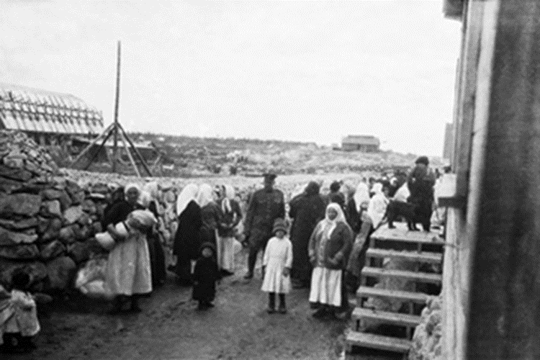
- This allows the government to ________________________ directly in the economy of the country for the first time.
- This gave the government the right to strip ordinary citizens of their _________________ _______________. Mail could be ___________________ and ____________________ ______________________ was suspended.
- The government also used the War Measures Act to limit the freedom of “_________________ ___________________” - recent immigrants and even citizens of Canada originally from the countries we were now at war with (i.e. Germany, Austria-Hungary, the Ukraine, etc.)
- Many enemy aliens were sent to ____________________________ ______________________for the duration of the war
- _____________________________ was also introduced – banned the publication of books and magazines in enemy languages

