History 12 Name ___________________________
Ms. Lacroix
McCarthyism
___
6
Source A - Statements made by Senator Joseph McCarthy to the Senate inquiry into communist penetration of the State Department, March 8, 1950
“Professor Owen Lattimore has been a ‘pro-communist’ for many years. He is the architect of our Far-Eastern policy and is the leading member of a group which has delivered China to communism and has done everything in the Far East that Russia wants. He is the top Russian espionage agent.”

Source D – Telegram reply to Senator McCarthy from President Harry Truman
“I read your telegram of February 11th from Reno Nevada with a great deal of interest and this is the first time in my experience, and I was ten years in the Senate, that I have heard of a Senator trying to discredit his own Government before the world. You know that isn’t done by honest public officials. Your telegram is not only not true and an insolent approach to a situation that should have been worked out between man and man but it shows conclusively that you are not even fit to have a hand in the operation of the Government of the United States”.
I am very sure that the people of Wisconsin are extremely sorry that they are represented by a person who has as little sense of responsibility as you have.”
Sincerely, Harry S. Truman

Source B – Statement on April 6, 1950 by Professor Owen Lattimore to the same inquiry mentioned in Document A
“I have never been a communist, or a sympathizer with communism. I have never held a position in the US government in which I could make policy. Far from accepting communist policy on China I vigorously supported Chiang Kai-shek when the communists were attacking him. By telling the kind of lies about the USA that Russian propagandists couldn’t invent, Senator McCarthy is accomplishing results for Russia which exceed their wildest hopes. I accuse Senator McCarthy of making the US government an object of suspicion in the eyes of the anti-communist world and, undoubtedly, the laughing stock of the communist governments. He has surrounded himself with crackpots, professional informers, and hysterics.”

Source E – Herbert Block, 1949
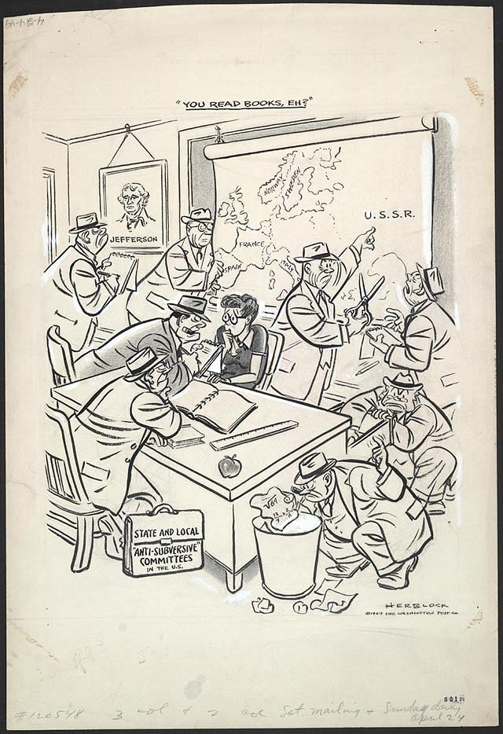

Source C – Edward R. Murrow – “See it Now”, 1954 television documentary
“McCarthy’s primary achievement has been in confusing the public mind, as between the internal and the external threats of Communism. We must not confuse dissent with disloyalty. We must remember always that accusation is not proof and that conviction depends upon evidence and due process of law. We will not walk in fear, one of another. We will not be driven by fear into an age of unreason, if we dig deep in our history and our doctrine, and remember that we are not descended from fearful men ...
We proclaim ourselves, as indeed we are, the defenders of freedom, wherever it continues to exist in the world, but we cannot defend freedom abroad by deserting it at home. The actions of the junior Senator from Wisconsin have caused alarm and dismay amongst our allies abroad, and given considerable comfort to our enemies. And whose fault is that? Not really his. He didn't create this situation of fear; he merely exploited it—and rather successfully.

Using the source documents and any information you gathered through our lectures, write a one-page persuasive argument DEFENDING McCarthy’s anti-communist stance and programs that sought out suspected traitors within America. (6 marks)

