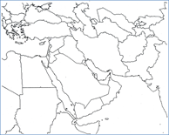Middle East Map Assignment
Directions:
- Label the following countries on your map with a different number:
Egypt Yemen Oman UAE Qatar Bahrain Kuwait Iran Iraq Turkey Jordan Israel Lebanon Syria Saudi Arabia
_____ /15 Points

- Write the corresponding names of each country on the numbered lines below.
- Color the (labelled) countries different colors (no two of the same colors next to each other)
- Label the following bodies of water and color them blue.
Mediterranean Sea Red Sea Arabian Sea Gulf of Oman Persian Gulf Caspian Sea Euphrates River Tigris River
_____ /8 Points

- Color all the remaining countries (the ones you did not label) one color so they fade into the background.
- NEATNESS counts. Your map should be a work of art! _____ /5 Points

_____ /28 Points Total

Name ____________________________________ Class Period ______ Date _______

Middle East Map
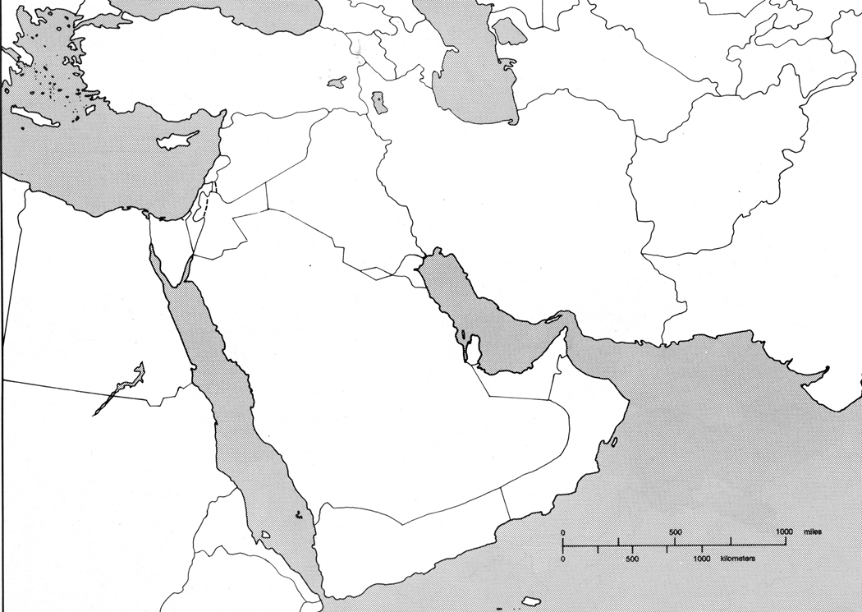

1. ___________________________________________  2. ___________________________________________  3. ___________________________________________  4. ___________________________________________  5. ___________________________________________  6. ___________________________________________  7.___________________________________________  8. ___________________________________________ | 9.___________________________________________  10. __________________________________________  11. __________________________________________  12. __________________________________________  13. __________________________________________  14. __________________________________________  15. __________________________________________

