The Korean War 1950-53

What caused it? [DUCKS]
1. President Truman was interested in the Far East:
- Domino theory:
Europe was not the only place where Communists were coming to power. In the Far East, too, they were getting powerful – China turned Communist in 1949. Truman believed that, if one country fell to Communism, then others would follow, like a line of dominoes. He was worried that, if Korea fell, the Communists would capture Japan.

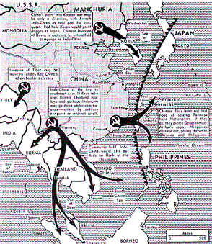

Source A
This map from an American magazine published 14th November 1950 shows how much they feared the spread of Communism in the far east.
Click on the map for a larger version.

- Undermine Communism:
In April 1950, the American National Security Council issued a report (NSC 68) recommending that America abandon 'containment' and start 'rolling back' Communism.
- Cold War:
Truman realised the USA was in a competition for world domination with the USSR. By supporting South Korea, America was able to fight Communism without directly attacking Russia.

2. Stalin, also, was involved in the Far East:

- Kim Il Sung visited Stalin
In 1949, he persuaded Stalin that he could conquer South Korea. Stalin did not think that America would dare to get involved, so he gave his agreement. Stalin saw a chance to continue the cold war and discomfort America, but ‘at arm’s length’ – without directly confronting the Americans. Kim Il Sung also went to see Mao Zedong, the leader of China, to get his agreement.

Source B
Asia is where the communist conspirators have decided to make their play for global conquest. If we lose this war, the fall of Europe is inevitable. There is no choice but victory.
US General MacArthur, speaking in 1950

- Syngman Rhee
In 1950, Syngman Rhee boasted that he was going to attack North Korea. It was a good enough excuse – the North Koreans invaded South Korea.

This started the Korean War.

Source C
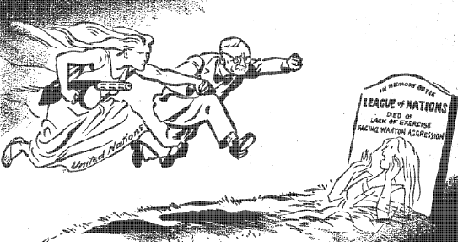
This cartoon by the British cartoonist David Low, from the Daily Herald (30 Jun 1950), shows Truman and the United Nations rushing to Korea’s aid.

Activity:
1. Study Source A. Why was Korea so important for the Americans?
2. Study Source C. What is the message of the source?
3. Take each of the DUCKS causes of the Korean War, and explain how each caused the war.

